Steps to Install and Setup Apache Airflow on Ubuntu 20.04 LTS
Apache-Airflow is a free & open source workflow management tool, written in Python. It is used for monitoring the workflow & is a workflow management solutions tool. We can easily visualize the data pipelines’ dependencies, progress, logs, code, trigger tasks, and success status.
There are some steps to install apache-airflow on ubuntu:
Step 1: Update the System.
Step 2: Install the required packages.
apt-get update
- Update the packages.
apt-get install software-properties-common
apt-add-repository universe
Step 3: Install the python3-pip.
apt-get update
Step 4: Install the required dependencies for Apache Airflow.
apt-get install python-setuptools
apt install python3-pip
Step 5: Install the Apache-Airflow on system.
apt-get install libmysqlclient-dev
apt-get install libssl-dev
apt-get install libkrb5-dev
- Install the python-virtual Environment.
- Here is the command output.
apt install python3-virtualenv
virtualenv airflow_example
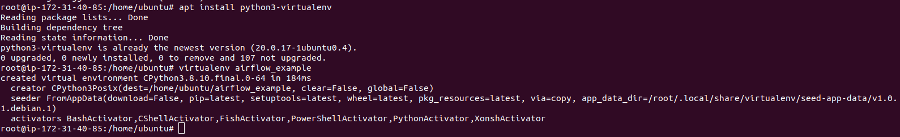
- Change the directory.
- Activate the source.
cd airflow_example/bin/
- Now ,install the apache-airflow.
source activate
- Here is the command output.
export AIRFLOW_HOME=~/airflow
pip3 install apache-airflow
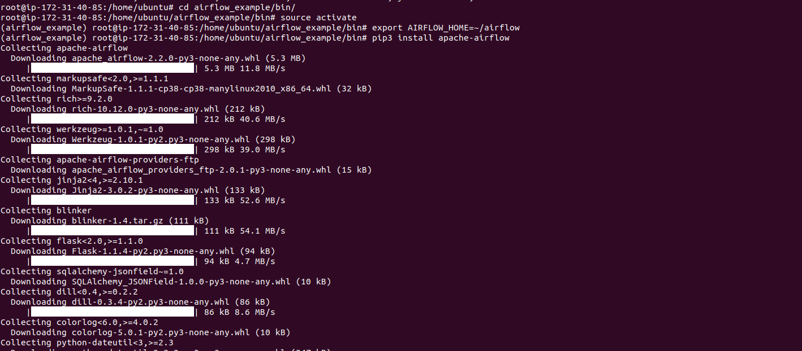
- Install typing_extension.
- Here is the command output.
pip3 install typing_extensions
- Run the following command.
- Here is the command output.
airflow db init
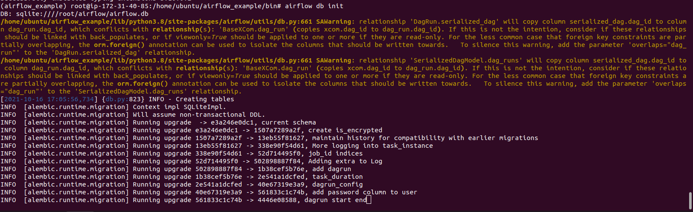
Step 6: Set the Apache-Airflow login credentials for airflow web interface.
For example:
airflow users create --username admin --firstname FIRST_NAME --lastname LAST_NAME --role Admin --email admin@example.org
airflow users create --username admin --firstname admin --lastname testing --role Admin --email admin@domain.com
- Here is the command output.
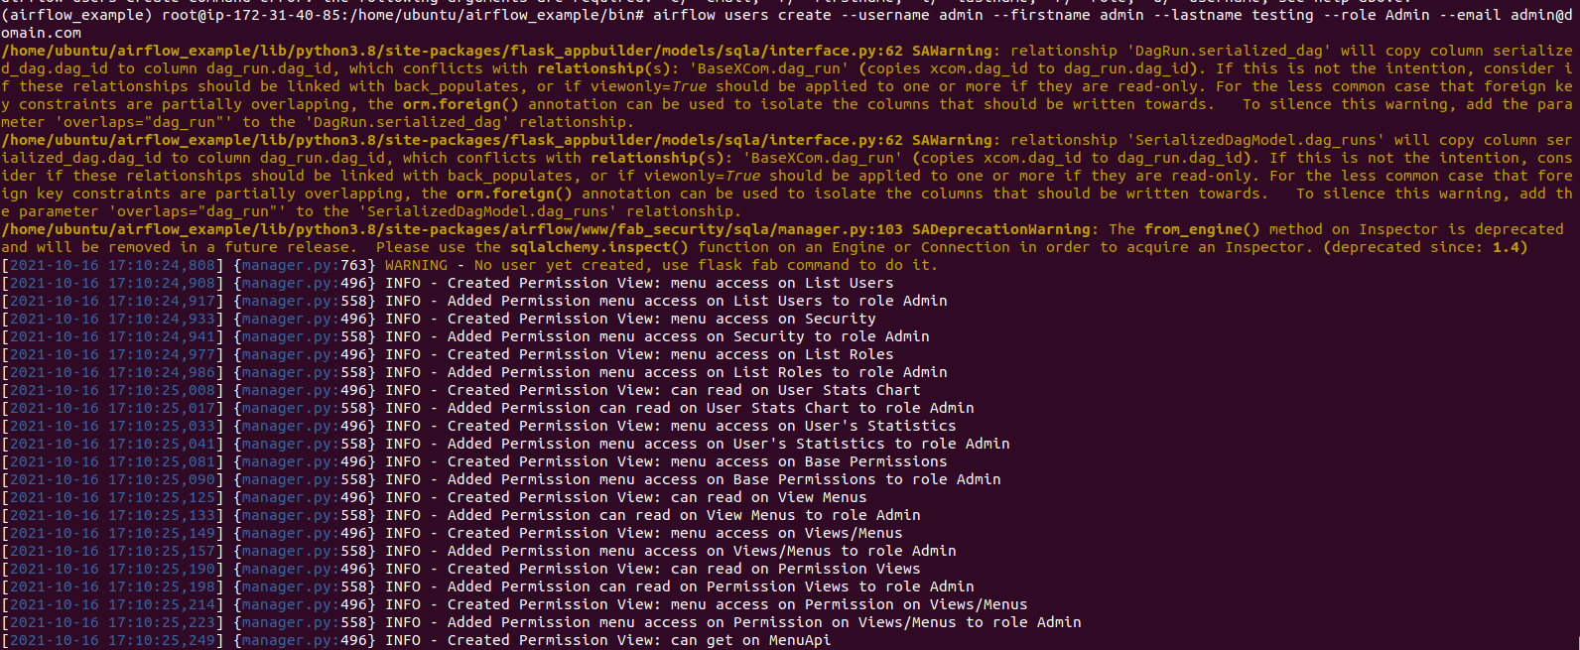

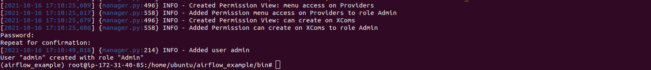

Step 7: Start the Apache-Airflow web interface.
- Here is the command output.
airflow webserver -p 8080
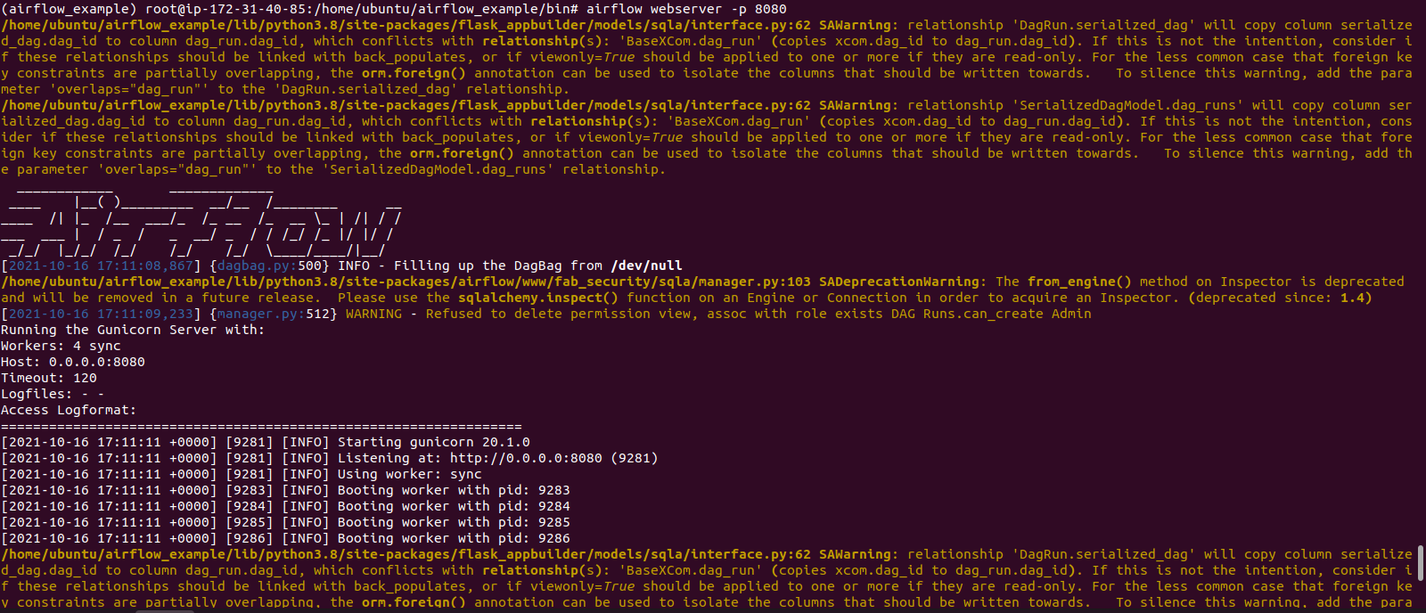
- Without stopping the command,Open the Apache-Airflow web interface using URL.
- Here is the command output.
http://server-ip:8080
- Provide the login credentials like username & password.
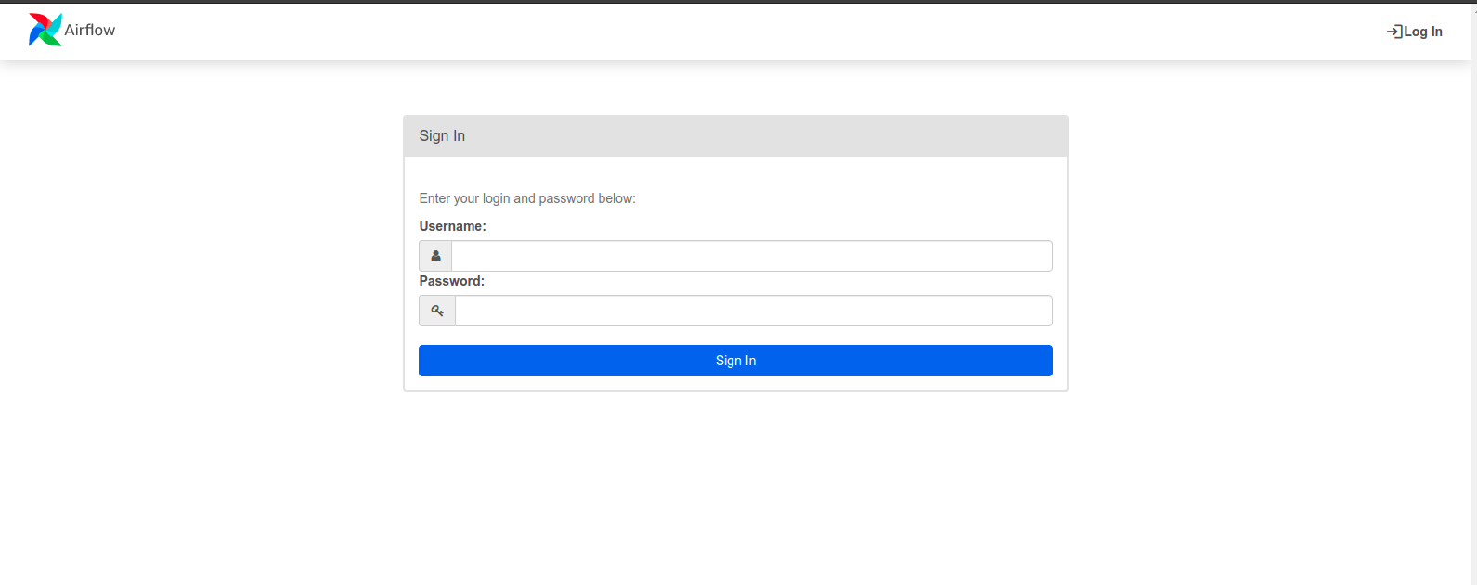
- Now, Apache-Airflow is Ready.
